Name : GOKUL BARADWAJ C
REG. NO. : 192512073

Simulation and BER Analysis of MIMO and Beamforming

Objective 1 :
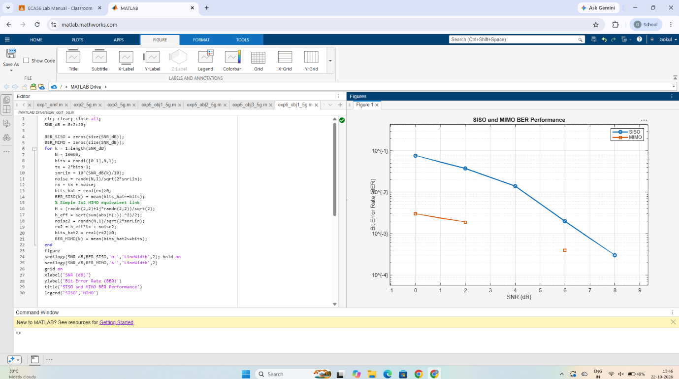

Objective 2:
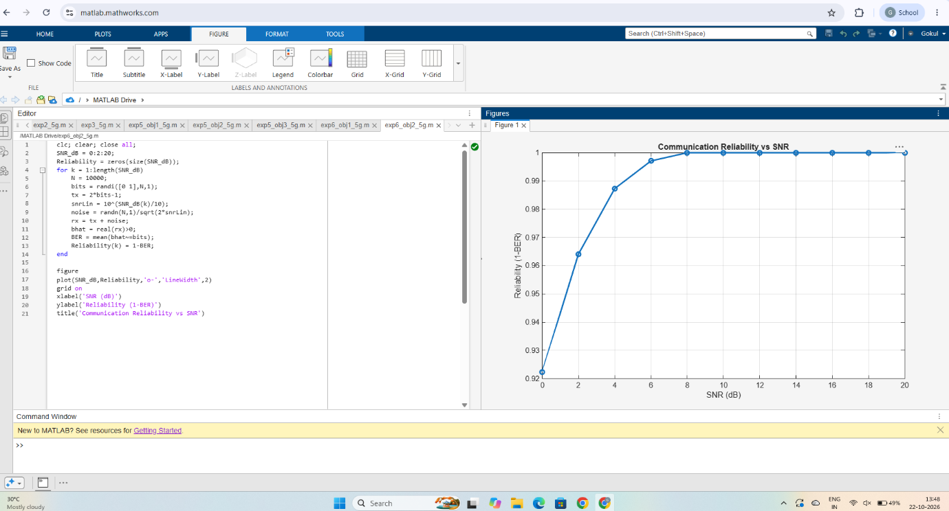
Objective 3:

